Problem 1

Problem: Write a C program to enter two numbers and perform all arithmetic operations. (+, -, *, /, %).

Solution:

Source Code
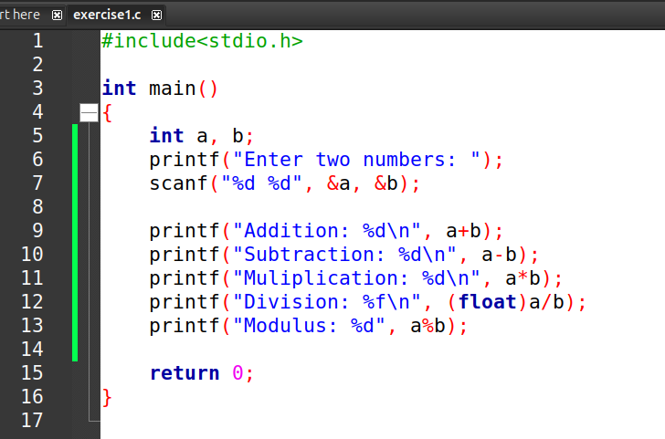

Input & Output
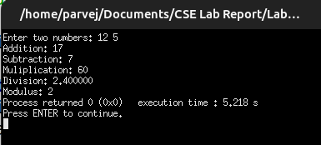

Problem 2

Problem: Write a C program to enter length and breadth of a rectangle and find its area.

Solution:

Source Code
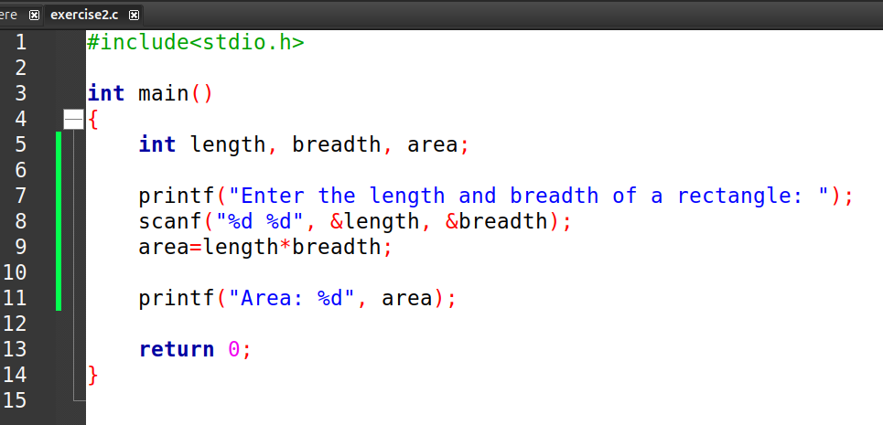

Input & Output

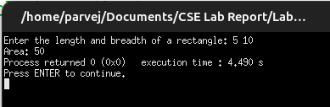
Problem 3

Problem: Write a C program to enter temperature in Celsius and convert it into Fahrenheit.

Solution:

Source Code
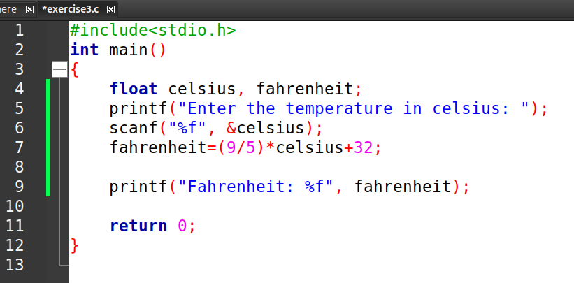

Input & Output

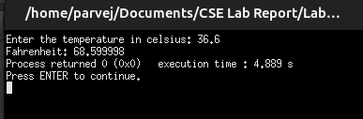
Problem 4

Problem: Write a C program to enter base and height of a triangle and find its area.

Solution:

Source Code
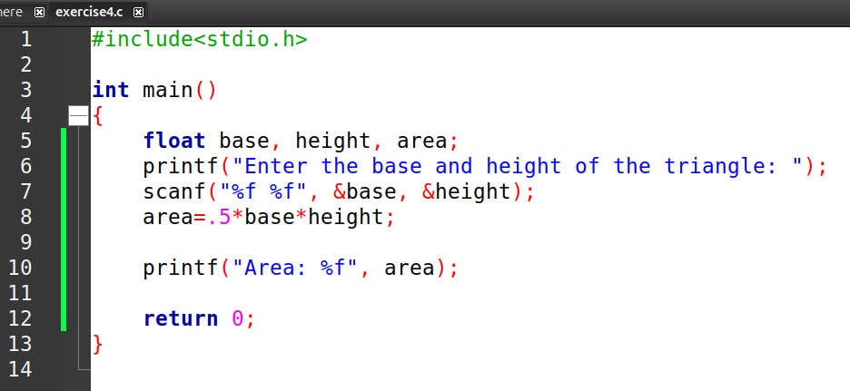

Input & Output
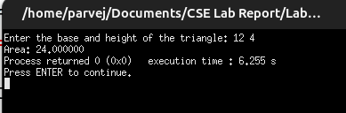
Problem 5

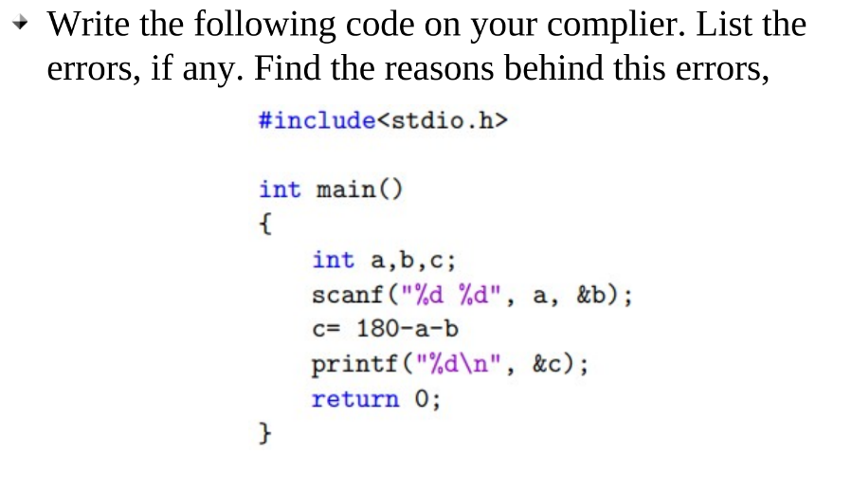
Corrected Code:

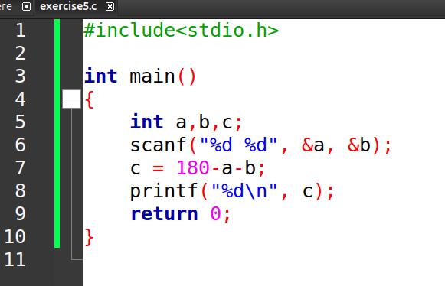
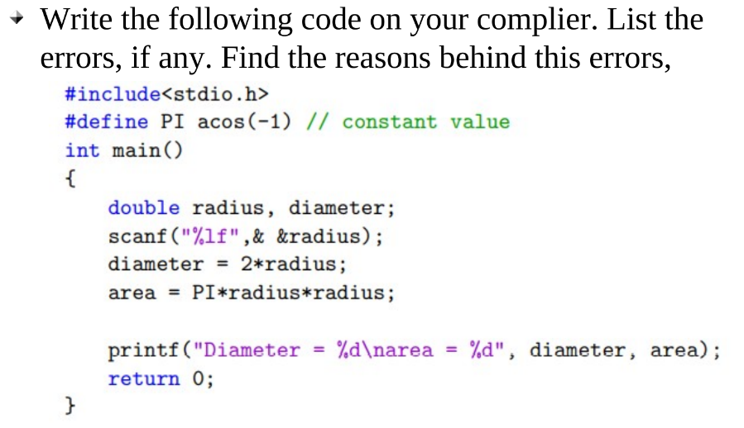
Problem 6

Corrected Code:

